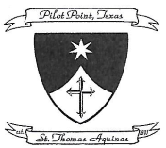
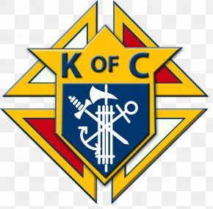
Knights of Columbus Council 2045
and
St Thomas Aquinas Catholic Church
Invite you and your family to a COVID safe
Fall Festival Grab and Go Lunch

When: September 27, 2020; 11:30am until sold out
Where: In front of the rectory
What: Pick up your Fall Fest Lunch and take it home to enjoy
Cost: $10/meal

Lunch will consist of
Pulled Pork and Sausage, Potato Salad and Beans

Meals can be pre-ordered on the Parish Website or by completing the attached form and submitting to the Church Office.
Meals may also be purchased the day of, subject to availably.

KC Grab and Go Fall Fest Lunch Oder Form
Name
Phone Number
Meals ordered |  | X$10/Plate =

Payment by Credit Card, Check payable to KC2045, or cash
Donations Accepted

